8/3/2019

**Dauchand’s Transport Service Website Proposal**

Rae-Ann Thomas-20170120

Advisor: Selris Mahabir

Course name: INFO 0213 Accounting for Business and Internship

Project title: Database and Website development

|  |  |
| --- | --- |
| Contents | Page |
| Introduction………………………………………………………………….......................  Swot Analysis………………………………………………………………........................  Problem statement……………………………………………………………………….....  Business strategy and SMART Goals……………………………………….......................  Project Planning /Scope:   * Project description, deliverables, acceptance criteria……………………………... * Project constraints, assumptions and estimated project schedule………………….   Needs analysis:   * Feasibility, Project requirements, MOSCOW analysis……………………………. * PEST analysis……………………………………………………………………… * Role of Stakeholders, investigation phase………………………………………… * Decision phase, cost benefit analysis………………………………………………   Design Phase:   * Wireframe………………………………………………………….......................... * Sitemap………………………………………………………………...................... * Use Case…………………………………………………………………………… * Database table and bookings ERD…………………………………… …………... * Dauchand’s transport service story board design……………………......................   Development……………………………………………………………………………….  Testing……………………………………………………………………….......................  Maintenance……………………………………………………………..............................  Conclusion…………………………………………………………………………………  References………………………………………………………………………………….  Appendix A………………………………………………………………….......................  Appendix B……………………………………………………………………………… | 2  3  4  5  6  7  8-9  10  11  12  13  14  15 |

**Introduction**

About Dauchand’s Transport service

This is a small local transport and tours company that operates in Trinidad and is owned by *Ms. Charmaine Dauchand and Ms. Erica Ottley.* This business has been in operation since November 2016.

Their services:

* private airport pickup and drop-off to persons going to and from the airport
* Cruise ship service transport
* private scheduled tours of specific landmarks or tourist attractions in Trinidad.
* Scheduled transport to clients’ desired destinations (beach, museums, restaurants etc.)

Their **target clientele** are tourists however locals who seek private transport or tours can also use this service.

Mission:

To provide safe, reliable and comfortable transport that satisfies customers customer needs and provide added value to our customer’s travel experience by helping them reach their desired destination.

Vision:

To be the preferred private transport service company by providing outstanding service, quality and adventure to our customers as they experience the wonderful island of Trinidad

Values:

Safety first, integrity, comfort and accountability.

**SWOT Analysis**

|  |  |  |
| --- | --- | --- |
| Internal factors | Strengths:   * Skilled and experienced drivers * Loyal employees and clients * Strong entrepreneurial spirit of the business owners * Updated technology in vehicle for comfortable and safe driving | Weaknesses:   * Only one van is used * Lack of resources to meet a wider audience * No marketing strategies or department |
| External factors | Opportunities:   * numerous holiday seasons approaching provide opportunity for increased business (influx of vacationers) * Social media profile | Threats:   * Increase in transport service/car rental service competitors * Increase in gas prices which affects level of operating costs * Government vehicle regulations |

# **Problem statement**

The main issue this organization faces is a decrease in clientele (see Appendix A for the diagram), and in turn dwindling profits. Presently, business cards are used to promote the business, however they have not established web presence or an online profile. Websites and social media profiles provide an efficient form of marketing, especially for Dauchand’s Transport Service. Clients (specifically their *target clients, tourists*) are responsible for more than half of this business’s profits, therefore great focus must be directed to generating a worldwide diversified client bases.

An online presence will:

1. Improve advertising effectiveness
2. Build business reputation
3. Easily access and expand target market
4. Keep generating customers, 24/7 service
5. Provide easy access to information for stakeholders

In order for this company to keep abreast with their competitors and new trends, a new website will be developed and implemented using the System Development Life Cycle (SDLC) structure and Agile methods for their benefit.

**Business Strategy**

Dauchand’s Transport Service does private transport and tours mainly to those visiting Trinidad. New strategies have been used to increase business brand by business cards, e-mail accounts and flyers. Those seeking this service can make phone or email reservations to the business owners. However, this new web profile strategy will promote future growth and decrease business marketing cost and time.

**SMART Goals/ objectives of the project**.

* Goal: To increase business awareness, engage prospects and drive traffic (10% increase in customers in 2 years starting after website launch on August 3rd 2019)

Objectives: well-researched SEO, well-organized content, user-friendly site

* Goal: To improve customer satisfaction and re-engage existing customers

Objectives: creative content, market site on social media to encourage comments,

* Goal: to run a more efficient and convenient business operation

Objectives: an online booking system, accurate and informative content, regularly update information

**Project Planning /Scope**

Project description:

* *Problem* addressed: This project will address the business’ marketing problem and efficiently help business exposure to their target audience.
* The *purpose* of the website is to give the business an online presence and to inform viewers worldwide of this available service beforehand so that they can arrange transport while in Trinidad.
* The website’s *objective* is to deliver instantly appealing and easily navigated content to ideal visitors

Project deliverables:

1. Site map/ wireframes
2. Data dictionary
3. Mock-ups
4. ERD diagram and Use case diagram

Project does not include:

1. Popups, animated banner ads
2. Links to external content or broken links
3. Poor navigation
4. Auto-play Site videos, Animated Gifs, music
5. Low quality images

Success/acceptance criteria:

1. All the requirements are achieved at the project completion time
2. Stakeholders are satisfied with final product.

Project constraints:

Time, Size of the project, budget and Quality (Does the website conform to requirements and is it fit for purpose?)

Project assumptions:

1. Project will follow the SDLC and Agile methodology throughout its completion
2. The website will be written using HTML, CSS, and JavaScript
3. Project scope will not change

Estimated project schedule

Ghantt Chart (see fig.1)

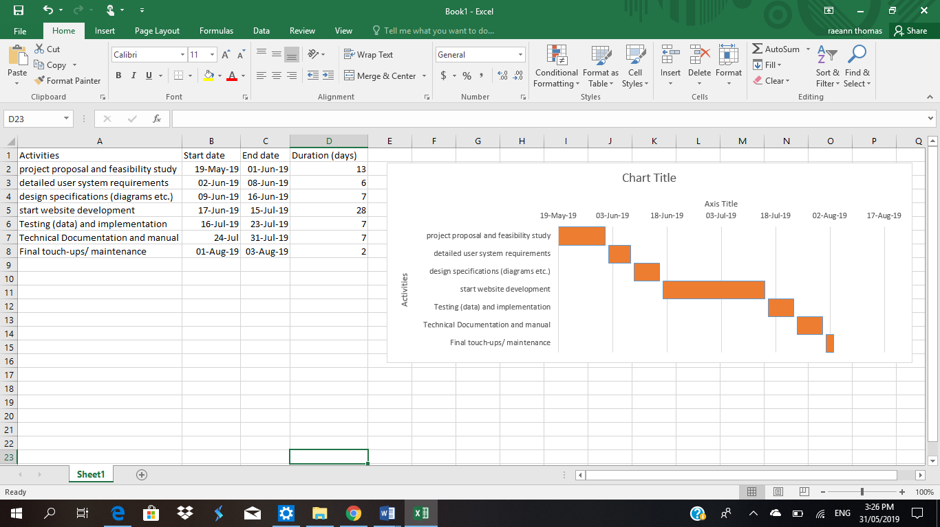

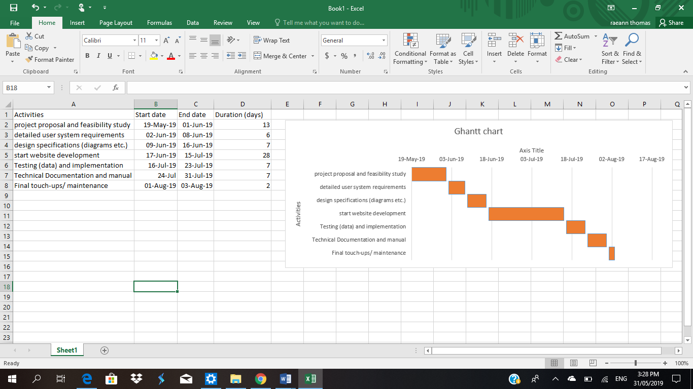

Fig.1

**Needs Analysis**

Purpose: Determine whether the website design and application best fits the needs of the stakeholders.

**Preparation phase:**

* Goal of the business: To increase customer satisfaction and experience
* This is a profitable business with plans of growth in customers and service.
* The business partners are open to technology and have already implemented technology and security to safeguard their vehicle and clients.

Is this project feasible?

* Economic feasibility- the development of this website is cost-free through the use of Atom and Mongo free services (see cost-benefit on page 12)
* Operational feasibility- This website will impact the current business system. Currently information is shared through contact cards. The website will decrease the need / use of business cards.
* Technology feasibility: Software and techniques need to complete this project are available
* Timeline feasibility: This website must be completed by 3rd August 2019

Project requirements:

1. Informative content, attractive design: Users should be able view information about the business, airport and cruise ship transport and vehicle info and general information about Trinidad.
2. Users should be able to select tours and receive more information
3. Integrate social media for easy content sharing, and users should be encouraged to comment on their experience
4. Responsive web design - Users should comfortably view site on any device
5. Booking System online form: Users should be able to specify a type of booking (airport, cruise, tours) to reserve transport in advance.
6. Site availability 24/7, with one hour for system maintenance and other intermittent maintenance
7. User should see welcome message and receive a thank you, and an email confirmation message after making a booking

MOSCOW ANALYSIS

Must have

* Informative, attractive and user friendly content
* Clear contact information

Should have

* Have Responsive web design
* 24/7 site availability

Could have

* Rating section
* Online booking system
* Integrate social media

Won’t have

* A log in or create an account capability

PEST Analysis: macro-environmental factors that impact the company

Political

Trinidad has enforced many motor vehicle and road traffic laws. Some changes where the speed limit allowed on the highway and also changes in the road signs and streets. Recently, all vehicles must pass a registration and inspection that was to inspect the condition of the vehicle. Failure to observe and keep abreast with all these new laws or recent changes would result in major expenses /consequences incurred on the business.

Economical

Trinidad has had an economic downturn. The inflation of gas prices, vehicle’s maintenance costs and insurance can affect the profits and operation of the business.

Social

There has been a dynamic population growth in Trinidad. Population has become more diversified and this can increase demand for transport around the country.

Technological

With the advance in technology, new ways of communication with clients has been introduced. Online booking of transport is now available. Transportation has become faster and more comfortable with the introduction of new features for vehicles. Private cars are becoming more popular and easy to obtain which can affect demand for public transport.

Define the real problem

Interview: I interviewed the owners for information on their business operations and problems, which are outlined in this project

Questionnaire: (see Appendix B for copy of questionnaire)

Observations: I observed how they usually generate clients and communicate with them. Business communication is mainly done over the phone which demands more business time.

Role of stakeholders:

* business owners: to make the final approval of the project proposal including all requirements presented and to make a profit
* Investors: to provide financial aid and review business performance and profits
* employees: provide high performance for increased wages
* clients: to request transport and expect quality service.

Sources of information needed to analyse users?

-interview with owner, questionnaires, reports of the existing system used to generate and keep account of the business and direct observation.

**Investigation phase:**

How does the existing system work? (business activity/procedure)

This system requires much phone time to make a reservation and document. However, a website can do this process in much less business time, and provide more visual information to the client which can be referred to at any time. (see fig.2 diagram of workflow) Fig.2

How can the existing business situation be fixed?

Add new technical resources: A website that will increase communication with clients conveniently and gather more information while using less business time.

**Decision Phase:**

What features would the new system offer?

Responsive web design, Booking System, comments section, social media links and email confirmation.

Why is this an improvement and the best available alternative?

A website is the longest lasting, cost effective, feasible solution. It has the most benefits at the lowest cost and reaches a wider audience efficiently.

Cost-benefit analysis

|  |  |
| --- | --- |
| Developer Task | Estimated costs ($) |
| Website development | 0.00 |
| Website hosting | 499.80/yr. |
| Domain name | 252/yr. |
| Website maintenance | 2,520/yr. |
|  |  |
| Total cost | 3,271.80 |

**Design**

Wireframe (home page)

Business Name Navigation links

Slideshow

Text

Text

Image

and

Text

Image

and

Text

Image

and

Text

Image

and

Text

Button

Text

Text

Text

Text

**tt**

Text

Image and text

Image and Text

Image and text

Jumbotron

Footer

Website Site Map



Bookings

About Us

Our Tours

About Trinidad

History

Cuisine

Music

Tourists attractions

Website Use Case diagram

Display information on tours and Trinidad

Browse

includes

Search tourist attractions by location

notifies

Request service

Create new booking

Userer

Business Owner

involves

Posted to database

determines

Post new events or tours

Webmaster

Data dictionary outlining a database table on **clients**

|  |  |  |  |  |  |
| --- | --- | --- | --- | --- | --- |
| Field name | Data type | Data format | Field size | Description | Example |
| first name | text | - | 20 | First name of customer | Bob |
| Last name | text | - | 20 | Last name of customer | Leston |
| Email | text | - | 20 | Contact email of customers | Bobleston@yahoo.com |
| Destination | text | - | 20 | Location where client wants to go | Las Cuevas  Beach |
| Date /Time of departure | Date/time | dd/mm/yyyy  00:00am/pm | 10 | Date and time the client wishes to book transport for | 26/08/2019  10:am-3:00pm |
| Number of persons | integer | - | 10 | The number of persons that will require transport | 3 |
| Type of transport | text |  | 20 | Description of the type of transport needed (**airport**-pickup/drop-off, **cruise ship** pickup/drop-off or **tours**) | Tour |

**Booking system** database ERD



Dauchand’s transport service story board design

**Development**

The development phase is the start of production. In this phase of the SDLC, we will look at two primary activities involved, the development of the IT infrastructure and the development of the database. To support the I.T infrastructure, the respected hardware and software will be purchased. The developers will purchase and register an appropriate domain name for the site (preferably dauchand’sTransportService.com.tt). This, in addition to the implementation of a webserver, will allow persons worldwide to connect to the business.

The developers will review the website design and storey board document to use as a guideline for website development. The required graphics, content and functionalities will be communicated to produce the site. With their trained eye, suggestions may be offered to improve such design to better meet requirements. These will be addressed and final approval will be given by the business owners through emails. This phase usually involves many development cycles such as the Waterfall model, Spiral Method and Agile development. However, in order to ensure constant communication and continuous feedback throughout the process, the Agile methodology will be focused on. This spiral model is iterative and incremental and allows the business owners to be engaged regularly and can ensure customer satisfaction.

The web programming languages used will be; HTML 5, W3.CSS, CSS, JavaScript. A database will also be set up to allow a search of tourist’s attractions by location and online bookings. Agile method will include XP (Extreme programming) implementation to offer quality assurance because code is continuously reviewed and issues are resolved faster. Based on the budget, a website hosting package will be purchased. It can include domain privacy, Spam protection, Unmetered Bandwidth, FTP site transfer, website caching, SSL, site analytics dashboard, Dedicated IP, SEO Tools etc.

**Testing**

At this phase, we will do a variety of testing to ensure that the website is functional, and efficiently meets the goals, objectives and requirements of the business. Each page of the site will be thoroughly tested for proper functionality, easy navigation, accurate information and grammar/spelling/punctuation. Browser testing allows the website to be tested on all major browsers to ensure compatibility and comfortable viewing. Quality assurance (QA) testing is implemented. Often times during this testing some bugs/glitches are found, recorded and must be addressed. The developers will be informed of such errors and adjust to suite. Then the website will be retested and this continues until it is stable and properly working 100%.

Two categories of testing are usually conducted: unit and integration testing.

Unit Testing: this testing is where individual units or parts of the website are tested one at a time. This ensures that all individual part function effectively.

Integration Testing: At this level, all units are combined and tested as a group, not individually. Although, individual groups may work, this test ensures that the units integrate and interact well together, without errors. To assist in testing, test drivers and test subs are used.

At the conclusion of testing, business owners and key stakeholders review website thoroughly for approval for site launch.

**Implementation**

Generally, when implementing a new system or project using the SDLC, there are four (4) changeover methods. The following are tailored to web development.

* Direct cut-over: older marketing information methods are cut and replaced by the new system (website) on a specific day. This requires that the new website is fully functional. Training must be done before site launch and support manuals must be readily available.
* Parallel: This involves the operating of both the new website (new marketing tool/ system) and the old system (old marketing processes). This ensures that the business will not be at a loss if the website proves problematic. However, this is the most expensive.
* Phased: This is where the old system is gradually introduced to replace the old system. Therefore, only some website applications are available for public use and the part of the old system it replaced is removed, one part at time. For example: Instead of the entire marketing system being replaced one time, the old booking system is replaced alone is removed by the booking website application. Over time the entire system will be replaced by the entire website application.
* Pilot: New website is only accessible and used by small number or clients/consumers (stakeholders). It is successful, then it can be expended for use with more people.

In conclusion, for this website project, our implementation will involve the pilot conversion to reduce risk of failure. It will be best to test website functionality on a small group of people first, receive feedback and if successful, expand the group. It allows business stakeholders and owners to understand the navigation of the website and comfortably use it to help customer learn about the business in a more efficient way and capture information better.

**Maintenance, support and security**

This is a very important phase in order to keep the website up and running. Proper maintenance ensures that the website works well and correctly adapts to the latest browsers and mobile phones. Over time, with the growth of a business, information may change or need to be added to the site. You may also include more user requirements, boost performance or add new capabilities. There are four basic types of maintenance:

*Corrective:* This is the testing and fixing of errors that may occur in the code or system, usually bugs.

*Preventative:* These are changes regularly done to decrease the chances of the website failing or requiring extensive repairs and long down times. It may include reconstructing the website.

*Perfection:* This is the implementing or new features or improvements to previous user requirements. It also includes the removal of ineffective features.  It should enhance the performance of the website.

*Adaptive:* This is the changes done to the website due to an environmental change (hardware/software change)

The following is a website to do list:

* Website backups: ensure database backups are done regularly automatically and are stored offsite.
* Test functionality to ensure all important website applications, such as the bookings form, works properly
* Perform regular software updates using security system software etc.
* Broken links: run link checker and look for broken links that may reduce search engine ranking.
* Check site speed: Use appropriate tools to identify issues slowing down the website performance.
* Use appropriate tools for search engine optimization (SEO) to ensure that nothing effects how the site is viewed by search engines.

**Conclusion**

In conclusion, this website will bring huge benefits for this business. It will not only attract more clientele but also make bookings and information easily accessible for all. It will generate more profits and build company awareness and the brand. This project will be a success because it was able to appropriately meet the business owner’s needs and the most important requirements of their stakeholders. It provided an added quality to the business name and kept the business more up to speed will this ever changing technology world. The owners were satisfied with the end result.

However, for future improvements the following shows some things I would’ve done differently or enhanced.

* Added google analytics to tract which tour persons most enjoyed.
* Include a rating section for each tour for customer feedback
* Create an online login where customer can view previous viewings and tours they enjoyed
* Added capability for customers to upload pics of their experience around places in Trinidad, in a gallery section.

**References**

Beisse. Fred*. A Guide to Computer User Support*. Course Technology, 1999.

Website info refer: <https://www.discovertnt.com/articles/Trinidad/Touring-Trinidad-pt-1-a-Walk-Around-the-Capital/165/3/23#axzz5usLGwZFH>

<https://www.lonelyplanet.com/trinidad-tobago/activities/day-trip-to-maracas-beach/a/pa-act/v-22374P4/358182>

<https://www.destinationtnt.com/caroni-swamp-and-bird-sanctuary/>

<https://www.destinationtnt.com/caroni-swamp-and-bird-sanctuary/>

<http://asawright.org/tropical-nature/birds-2/>

<http://www.mountstbenedictabbey.org/about.html>

https://www.meppublishers.com/trinidads-mount-st-benedict/#axzz5uyJDtJCU.

<https://www.destinationtnt.com/pitch-lake/>

<https://www.lonelyplanet.com/trinidad-tobago/activities/day-trip-to-maracas-beach/a/pa-act/v-22374P4/358182>

<https://www.discovertnt.com/history#axzz5v0HQUnhX>

food, drink, restautants;

<https://trinichow.com/2012/04/26/5-must-try-foods-in-trinidad-tobago/>

<https://thatgirlcookshealthy.com/caribbean-sorrel-drink-recipe/>

<https://www.transat.com/en-CA/hotels/brisas-trinidad/restaurants-bars>

<https://www.fodors.com/world/caribbean/trinidad-and-tobago/experiences/news/trinidads-must-eat-street-foods-11367>

**Appendix A**

**Appendix B**

Dauchand's Transport Service

Please answer the following questions:

How long has this business been operating?

What are the goals of the organization?

How many people are employed at your company?

What was the annual revenue within the last year?

Explain how your company does business?

What aspect of your current business operations customers like most?

Does your company do business online?

What technology is used in your company and how has the organization adapted to it?

What marketing channels do you use to promote your business?

Who is your target market/customer?

Any challenges within the business (workflow, management, resources, personnel, etc.)? If yes, name some.

Do you think the business is operating at its peak potential? If no, explain why.

Give some suggestions that you think can improve business operations.